(DHANKAWADI, PUNE-43)



MINI PROJECT REPORT ON

“ART GALLERY”

SUBMITTED BY

Harsh Kumar (3077)

Ashwin Dhole (3078)

Samrudhi Naik (3080)

Dharati Kunte (3081)

(Third Year Information Technology)

UNDER THE GUIDANCE OF

Prof. J. K. Kamble

**Pune Institute of Computer Technology**

**For Academic Year 2017-18**

**ABSTRACT**

This Project is developed for Art Gallery System and interaction between artist and customers.

This System will provide an platform for the artists to show case all their paintings and customers can easily buy the paintings from site from their desired artists. Customer are provided with their own login so that they can easily access the site they wish for, Such flexibility is been provided by us.

**ACKNOWLEDGEMENT**

We thank to our college and our Principal Dr. P.T.Kulkarni for providing us opportunity to work on this project.

We also thank our department and professors Prof.J.K.Kamble, Prof. S.A.Jakhet

e and Prof.R.B.Murumkar for providing us valuable guidance and support due to which we are able to complete our mini-project successfully.

We than all those people who have directly or indirectly helped us to complete our mini-project.

Mr. Harsh Kumar (3077)

Mr. Ashwin Dhole (3078)

Ms. Samrudhi Naik (3080)

Ms. Dharati Kunte (3081)

|  |  |
| --- | --- |
| **TITLE** | **PAGENO** |
| **1. Introduction** | **3** |
| **2. Scope and limitations** | **4** |
| **3.Flow Diagram** | **5** |
| **4. E-R Diagram (description)** | **6** |
| **5.Normalization(up to 3NF)** | **7** |
| **5. coding –Insertion, deletion, updation, image-uploading view Design (description)** | **8** |
| **5. coding design(form snapshot)** | **9** |
| **6.User Interface Snapshots** | **13** |
| **7.Conclusion** | **29** |

# INTRODUCTION

ONLINE ART GALLERY SYSTEM is a website designed primarily for the interaction in between artist’s and customer. This system will allow artist to increase scope of business by reducing the labor cost involved. The system also allows to quickly and easily manage an online menu which customers can browse and use to place orders with just few clicks.

Online ordering system that we are proposing here, greatly simplifies the ordering process for both the customer and the artist. System presents an interactive and up-to-date menu with all available options in an easy to use manner. Customer can choose paintings they desire to buy from artist and can place an order which will land in the Cart. Customer can view all the order details in the cart before checking out. At the end, customer gets order confirmation details. Once the order is placed it is entered in the database and retrieved in pretty much real time. This allows admin to quickly go through the orders as they are received and process all orders efficiently and effectively with minimal delays and confusion.

The languages used to build this application are HTML,PHP and CSS at client facing whereas MySQL database at the back-end.

**The main modules in this Project are as follows:**

* **Web Ordering System Module**

This module provides the functionality for customers to place their order and supply necessary details. Users of the system, namely customers, must be provided the following functionality:

* Create an account.
* Manage their account.
* Log in to the system.
* Navigate the artist’s menu.
* Select the painting from the menu
* Add that painting to their current order.
* Review their current order.
* Remove an item/remove all items from their current order.
* Provide payment details.
* Place an order.
* Receive confirmation in the form of an order number.
* View order placed.
* **Menu Management System Module**

This module provides functionality for the power user-administrator only. It will

not be available to any other users of the system like artist or customers. Using a

graphical interface, it will allow an Admin to manage the menu

that is displayed to users of the web ordering system:

* Add/update/delete artist information to/from the artist’s biography.
* Add /update/delete paintings to/from the artist’s biography.
* Update price for a given paintings.
* Update additional information (description, photo, etc.) for a given paintings.

Before customers can actually use this system, functionality provided by this component will have to be configured first. Once the initial configuration is done, this will be the least likely used component as menu updates are mostly seasonal and do not occur frequently

* **Order Retrieval System Module**

This is the most simplest module out of all 3 modules. It is designed to be used only by employees, and provides the following functions:

* Retrieve new orders from the database.
* Display the orders in an easily readable, graphical way.

# E-R Design

# 

# SCHEMA DEFINITION

# Table List

1. Customer
2. Order
3. Menu
4. Payment
5. Admin

# Coding Snapshots

# User Interface Snapshots

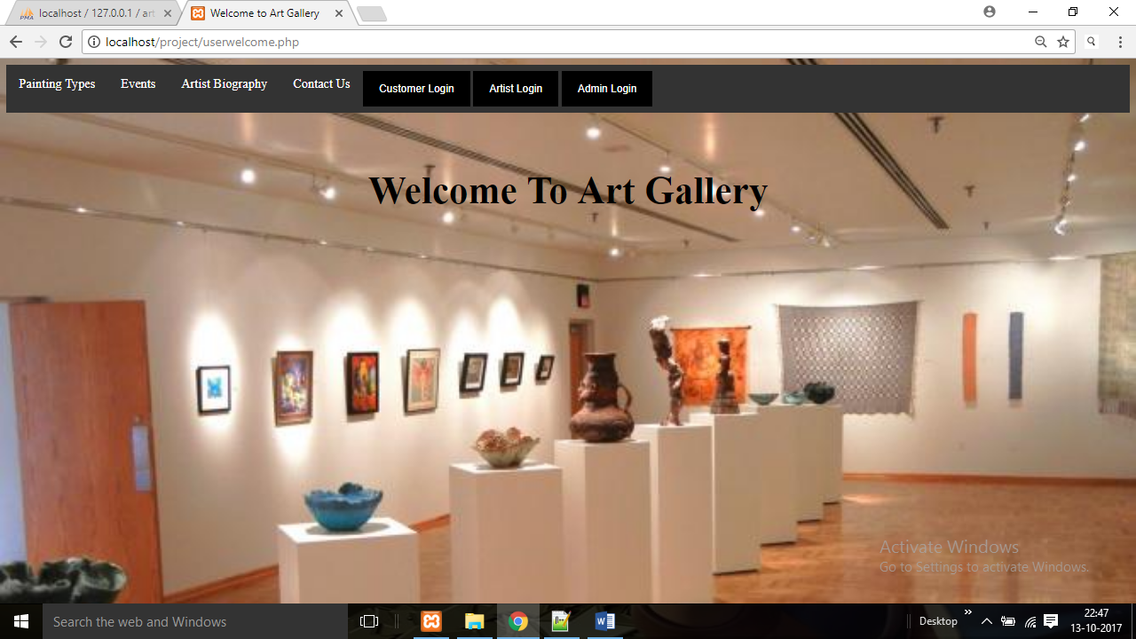

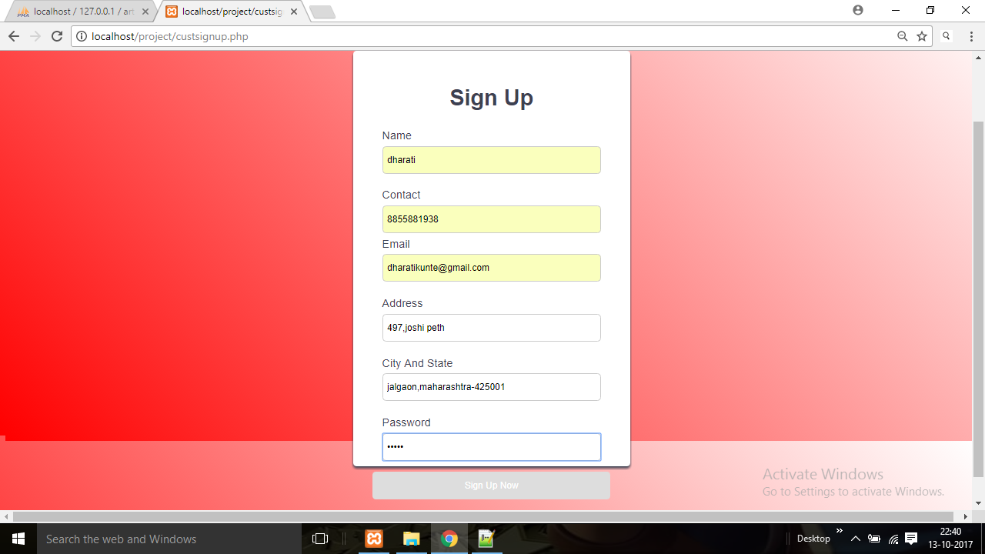

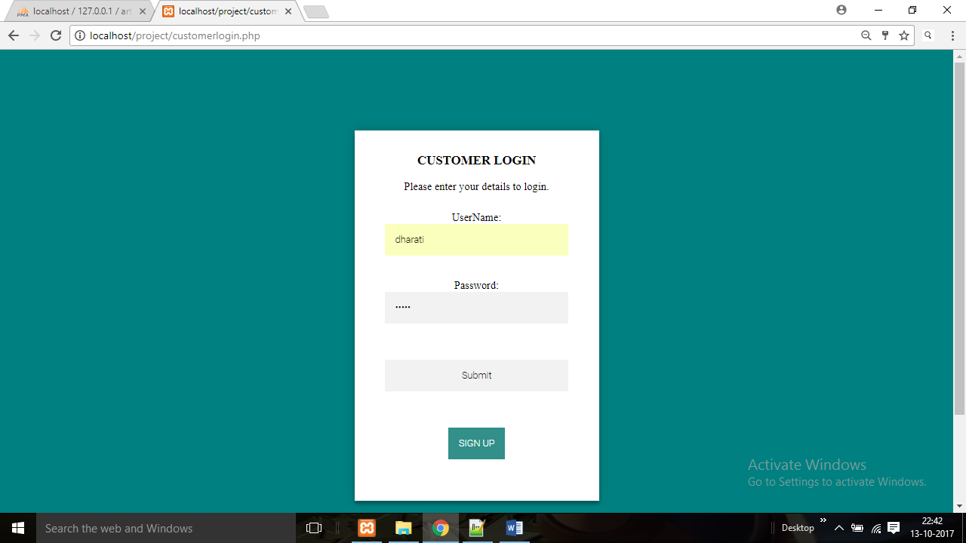

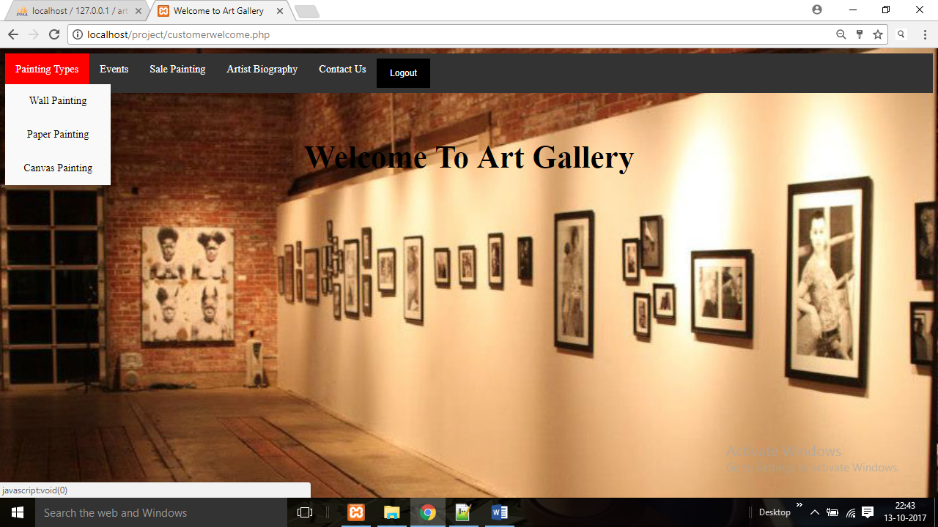

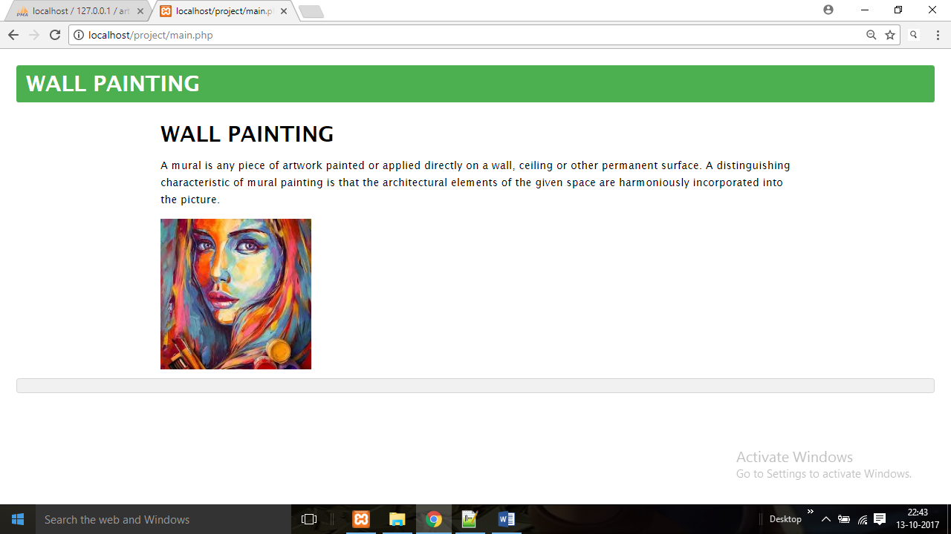

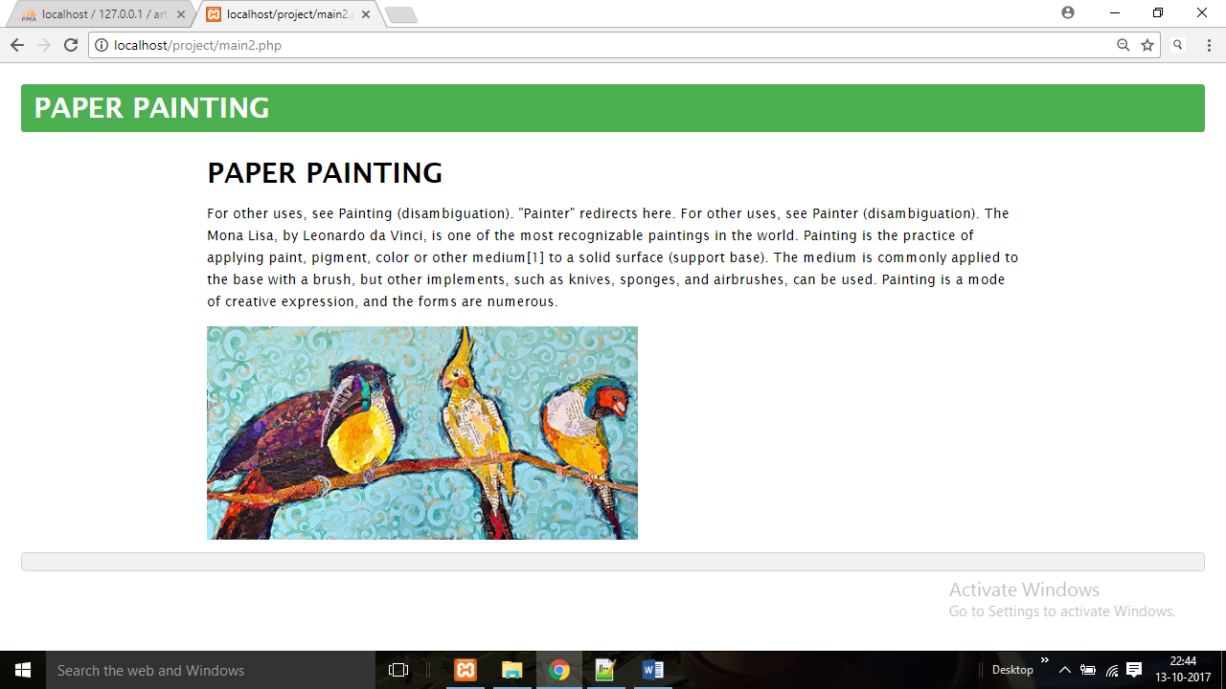

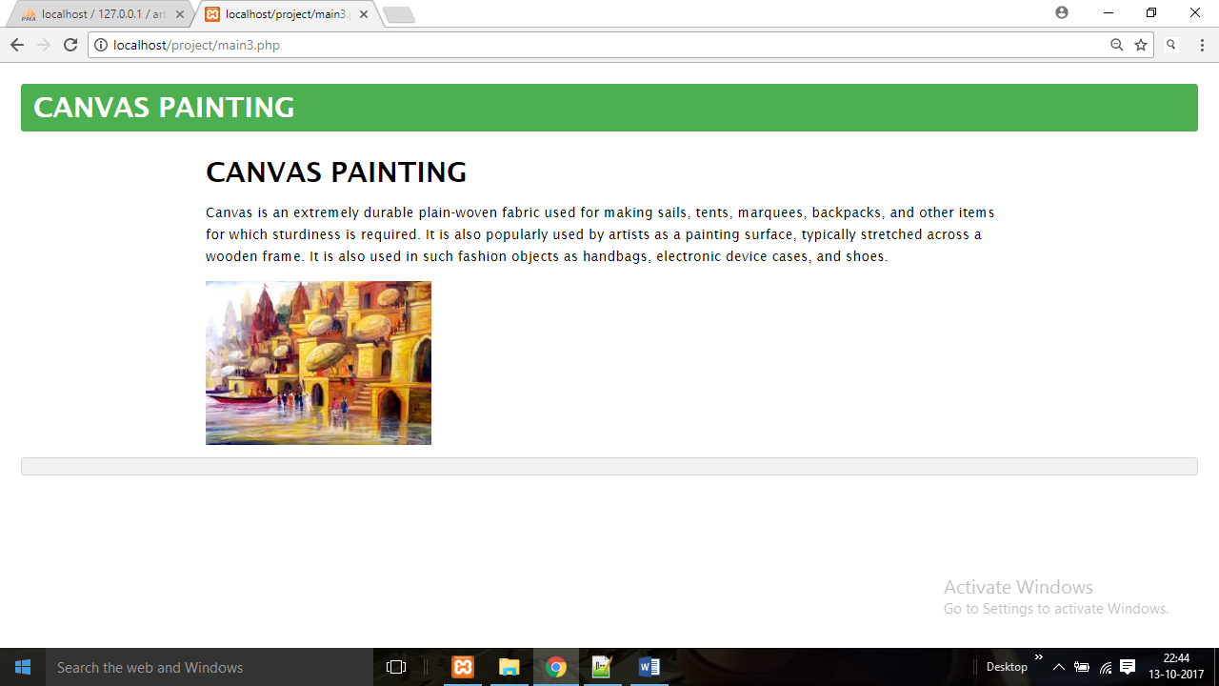

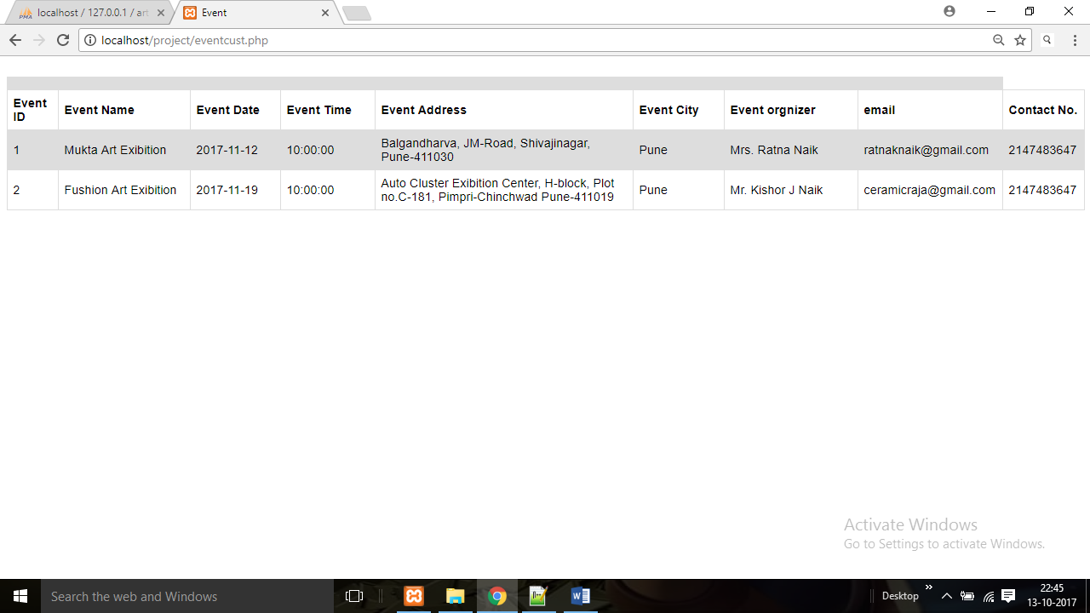

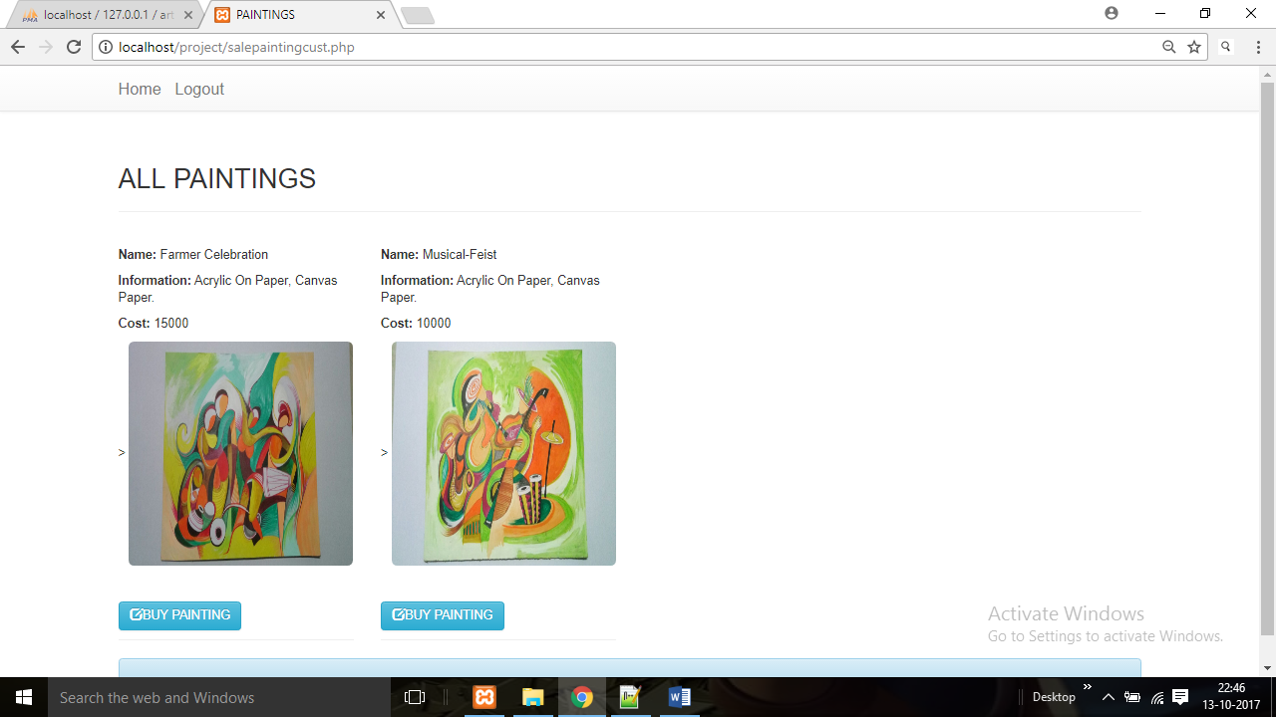

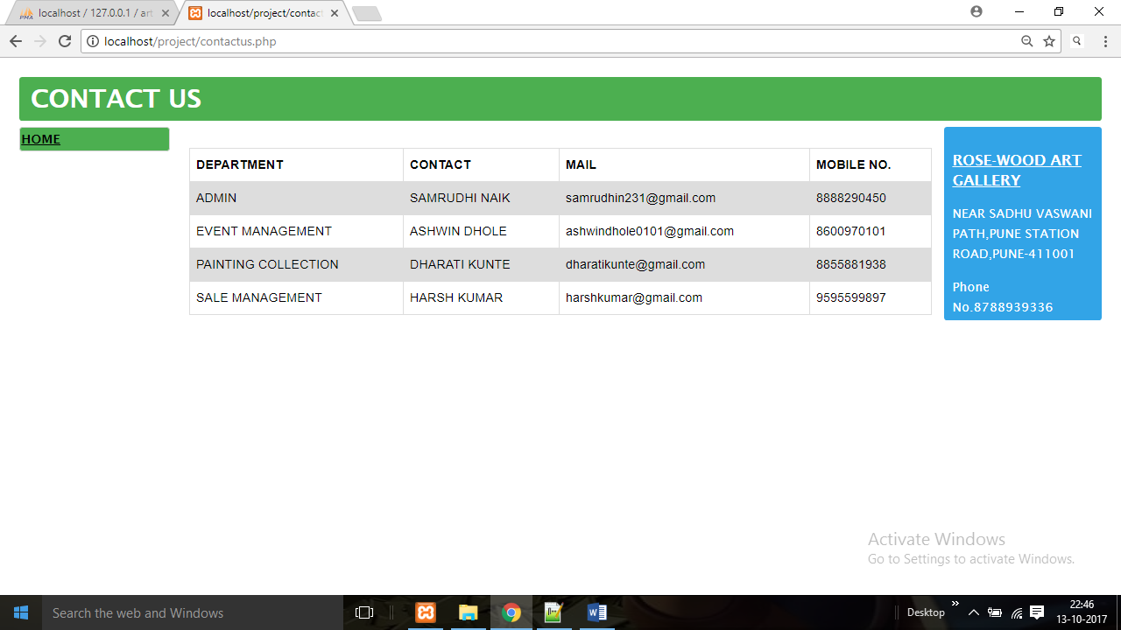

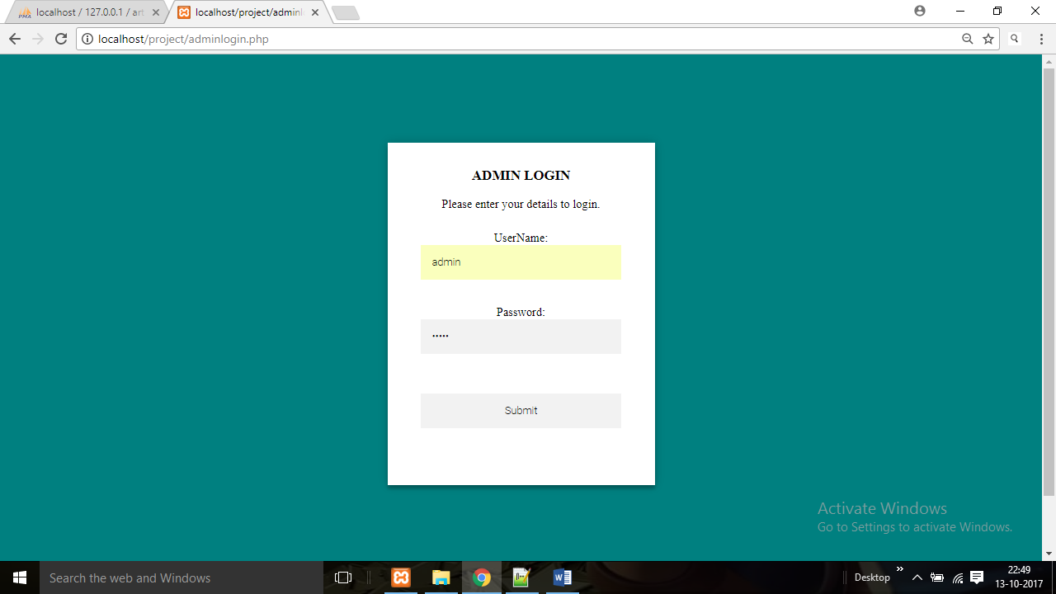

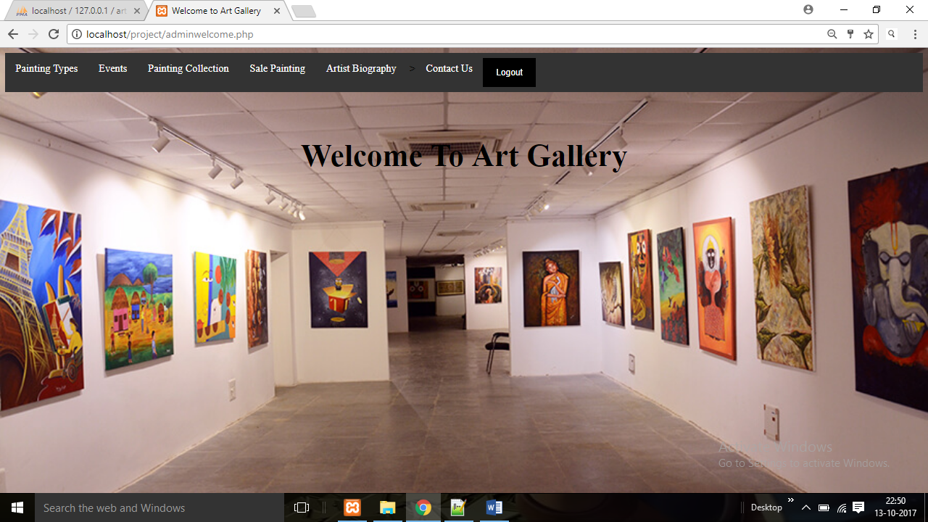

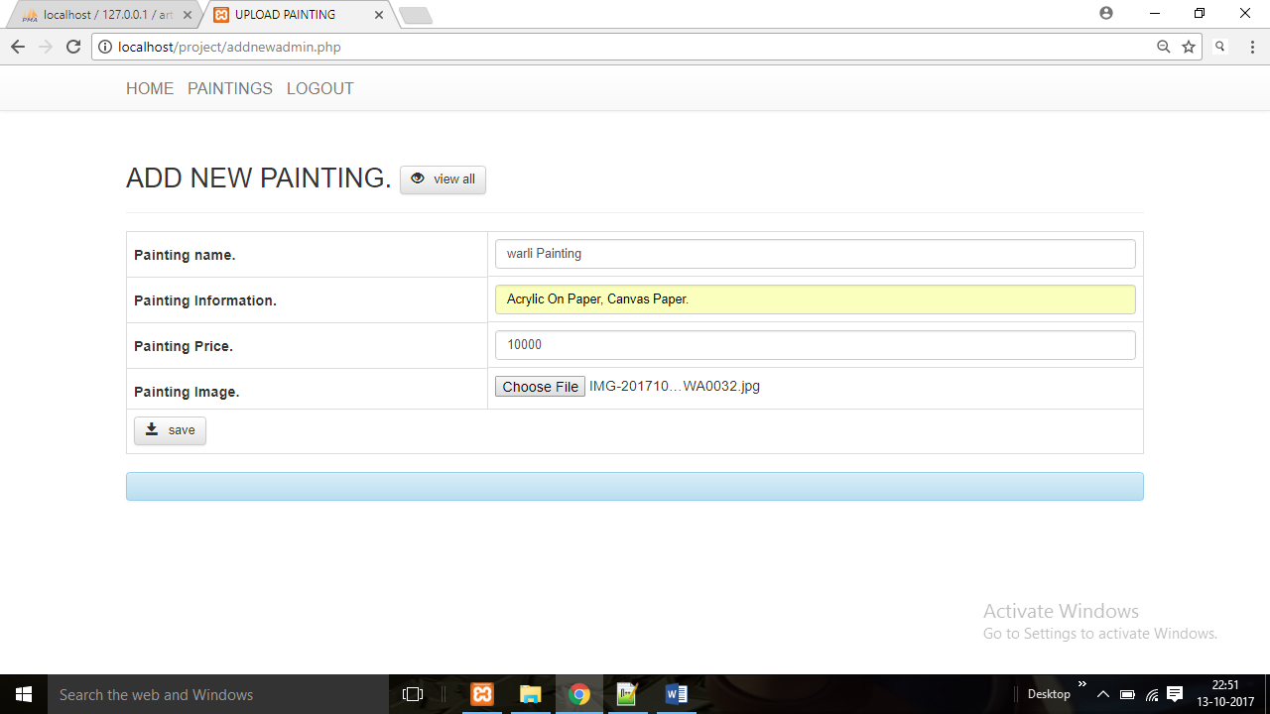

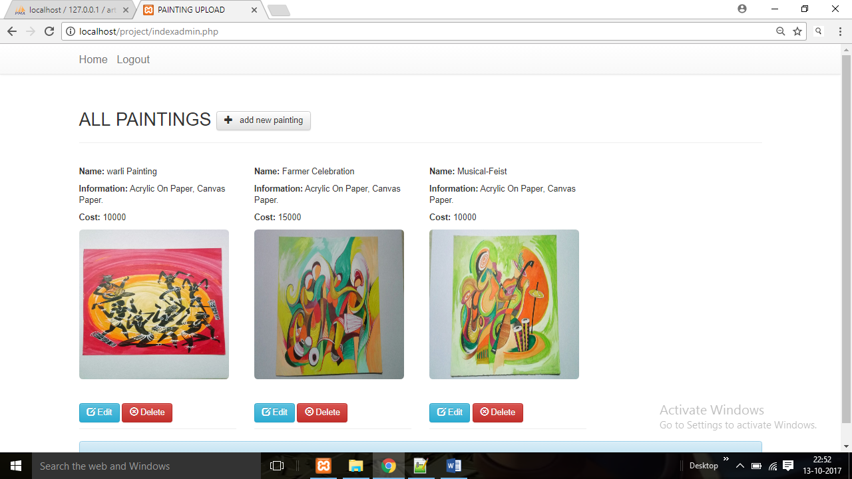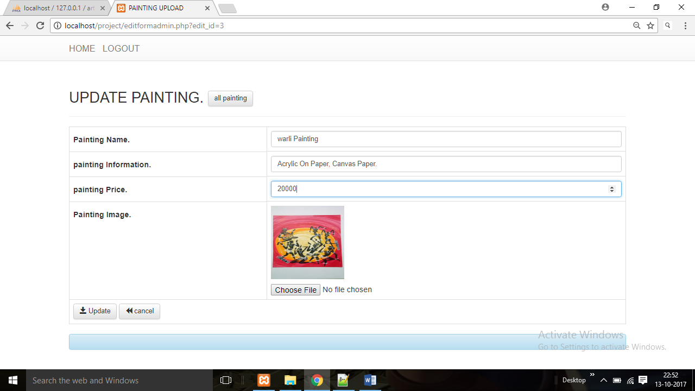

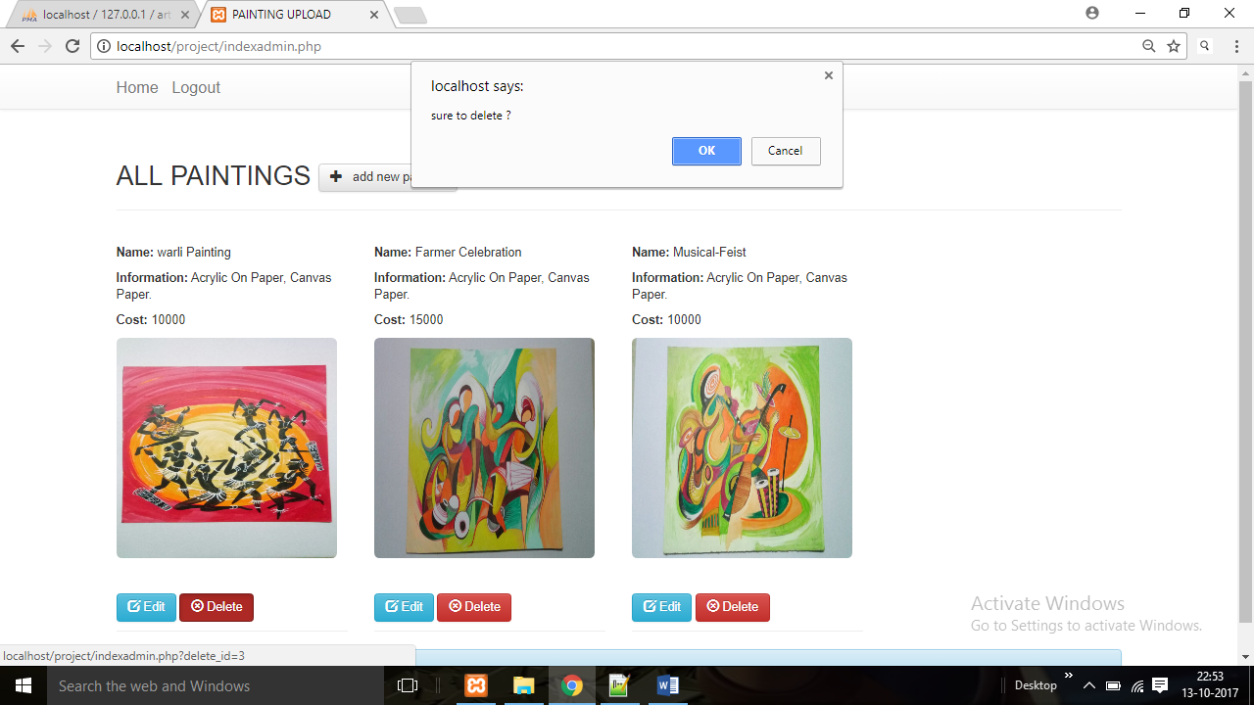

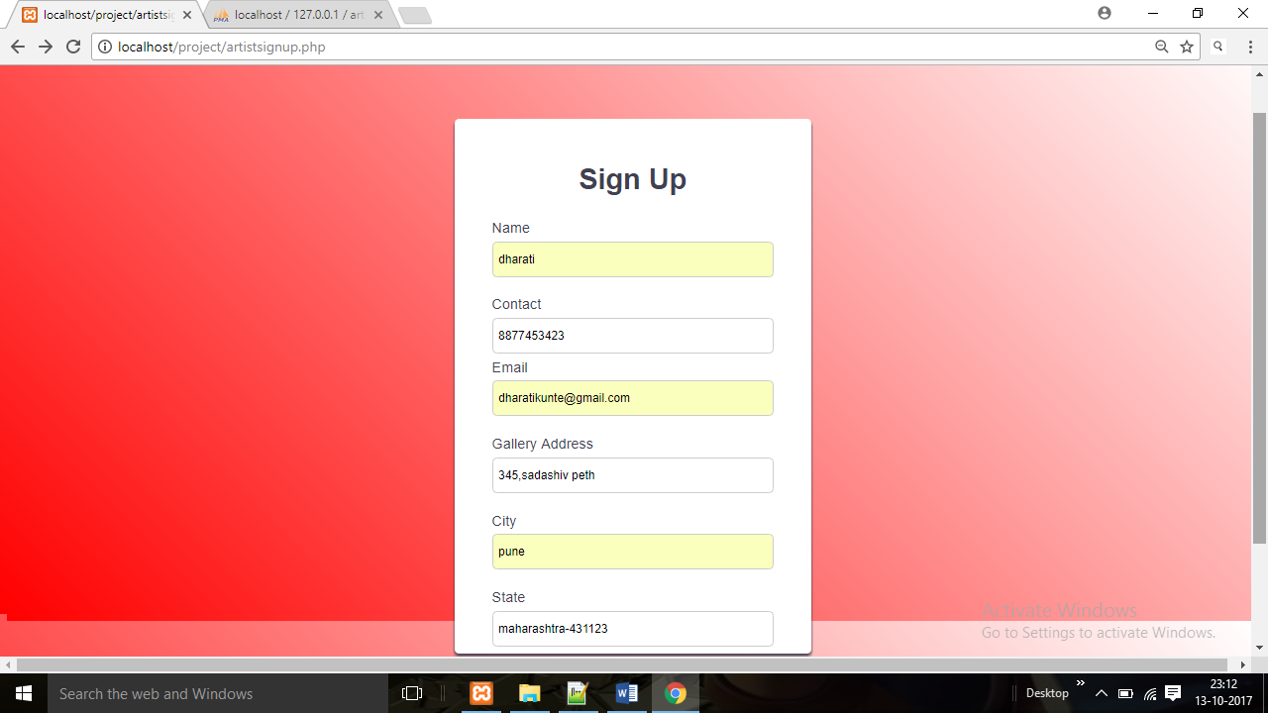

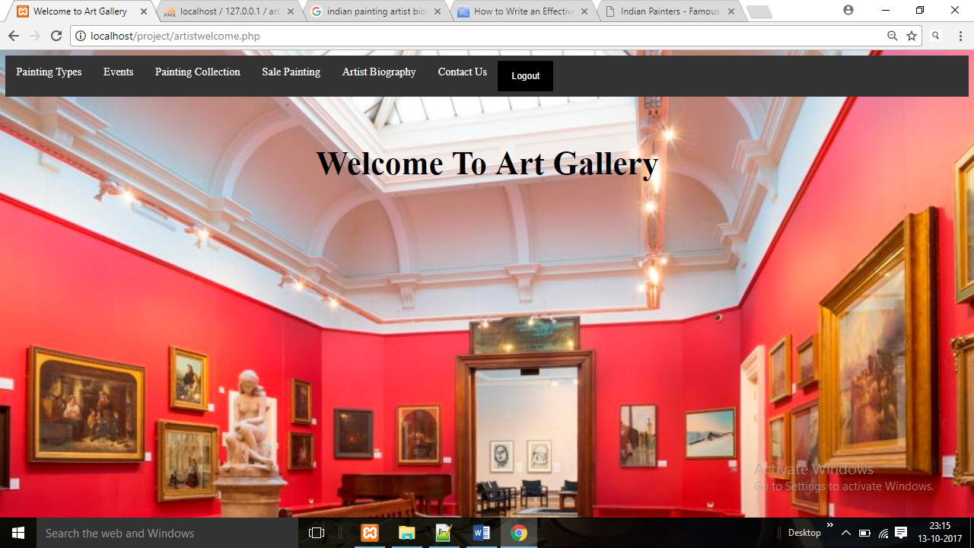

# CONCLUSION

The three parts which are essential for this project are User interface, Creation of relational database and SQL engine.

The Project is entirely based on database management system concepts. The back-end use for project is MySql and front-end is PHP and Java. The Coding of Sql queries through PHP is properly done. The project is very feasible.

The software engineering concepts are used to implement the project. The requirement analysis is understood and done for this project.

**REFERENCES**

[**www.google.com**](http://www.google.com)

[**www.w3schools.com**](http://www.w3schools.com)

[**www.w3resources.com**](http://www.w3resources.com)

[**www.youtube.com**](http://www.youtube.com)